**Colt Voice REST Billing APIs Guide**

|  |
| --- |
| Copyright © |
| No part of this document may be reproduced or adapted in any form, including photocopying or storing it by electronic means, except as is necessary for the purpose of the recipient's dealings with Colt, without the written permission of Colt. Any copies made of any part of this document shall include the notice:  © 2025 Colt Technology Services. The Colt name and logos are trademarks. All rights reserved. |
| No information contained in this document shall be disclosed to any third party without the written permission of Colt. |

CDR APIs Implementation Guide

**Document Version** 1.0

**Release Date** 18/03/2025

**Document History**

Soft copies of this document are maintained under change control, but hard copies are not. This may not be a printout of the latest version.

**Revision history**

|  |  |  |
| --- | --- | --- |
| Revision | Date | Description |
| **1.0** | 18th March 2025 | Document Launch |

Contents

**1.** **Introduction** 5

1.1. Access & End-Point URLs 5

1.1.1. Error handling 6

1.2. How to get access to new REST APIs, Colt API portal & support 7

**2.** **Authentication** 8

2.1. Oauth 2.0 Authentication 8

2.1.1. API Details 8

2.1.2. Input parameter(s) 8

2.1.3. Error handling 8

2.1.4. Response samples 8

**3.** **Billing APIs** 10

3.1. Resource names 10

**4.** **Unrated CDRs** 11

4.1. Get Unrated CDRs 11

4.1.1. Description 11

4.1.2. Input parameter(s) 11

4.1.3. Response 12

4.2. Post Consolidated Unrated CDRs 12

4.2.1. Description 12

4.2.2. Input parameter(s) 13

4.2.3. Response 13

4.3. Get Consolidated unrated CDR 14

4.3.1. Description 14

4.3.2. Input parameter(s) 15

4.3.3. Response 15

4.4. CDR file details and format 16

4.4.1. CDR File Format 16

*4.4.2.* *Character Coding* 16

*4.4.3.* *File Mark-up Coding* 16

*4.4.4.* *Compression/Decompression Algorithms* 16

*4.4.5.* *File Name* 16

4.5. Call Detail Record format 17

4.6. Sample Call Detail Record 20

**5.** **Rated CDR** 22

5.1. Description 22

5.2. Input parameter(s) 22

5.3. Response 22

**6.** **Non usage report** 24

6.1. Description 24

6.2. Input parameter(s) 24

6.3. Response 24

**7.** **How to save/extract binary file** 26

**APPENDIX A: API Specifications** 28

OAS Specification for Authentication 28

OAS Specification for Billing APIs 28

**Appendix B: Country Codes** 28

# **Introduction**

We now support Next Gen REST APIs for call detail records (CDRs) and non-usage charges.

Our Next Gen APIs:

* Conform to the Industry standard REST-JSON APIs
* Align with TMF conventions
* Support OAuth2 and JWT based authentication
* Support open API specifications (earlier swagger)
* Support flexible version management
* Offer a standard format for numbers, date-time, etc.
* Optimize fields
* Do not change synchronous/asynchronous API behavior

## Access & End-Point URLs

Colt REST APIs can be enabled in these environments below:

* Production: live environment. You will be able to retrieve your (un)rated CDRs and non-usage charges.
* Sandbox: non-production environment for testing the production version of the APIs. Please note no CDR nor non-usage files will be available for testing.
  + Beta: non-production environment for testing new features before a release, with an upcoming version of APIs. Only available before a new release.

|  |  |
| --- | --- |
| Interface | Production |
| **REST** | **Authentication API**  End point URLs:  Production: https://apis.colt.net/authentication/v1/oauth/token  Sandbox: https://sandbox.apis.colt.net/authentication/v1/oauth/token |
| **REST** | **Billing APIs**  End point URLs:  Production: https://apis.colt.net/usageManagement/v1/resourceName  Sandbox: https://sandbox.apis.colt.net/usageManagement/v1/resourceName  ***resourceName:*** allowed resource names are as below.   * unratedCallDetailRecord * generateConsolidatedUnratedCallDetailRecord * consolidatedUnratedCallDetailRecord * ratedCallDetailRecord * nonUsageReport |

### Error handling

#### Error Schema

|  |  |
| --- | --- |
| description: | Used when an API throws an Error, typically with a HTTP error response-code (3xx, 4xx, 5xx) |
| code* | string *example: ERR01*  Application relevant detail, defined in the API or a common list. |
| reason* | String  Explanation of the reason for the error. |
| message | String  More details and corrective actions related to the error. |
| status | string *example: 401-02*  HTTP Error code extension |

**Header:**

|  |  |  |
| --- | --- | --- |
| Name | Description | Type |
| Content-Type |  | string *Example: multipart/form-data; boundary=645501572420247968528808* |
| APIGWExceptionSystem |  | string |
| APIGWExceptionCode |  | string |
| APIGWTrackingId | Id to track the request end to end | string *Example: abcd456e-d45645-dfaafda-1232345667dd* |

#### Example

Below is the TMF compliant error payload:

{

"code": "ERR01",

"reason": "string",

"message": "string",

"status": "401-02"

}

## How to get access to new REST APIs, Colt API portal & support

You can use our new [**API developer portal**](https://eur01.safelinks.protection.outlook.com/?url=https%3A%2F%2Fdeveloper.colt.net%2F&data=05%7C02%7CYamini.Choudhary2%40colt.net%7C4d899794678c44b9fbc508dd65729c13%7Cb859cf7eff8a40bbbd0fda56e6dc0eb8%7C1%7C0%7C638778265106464403%7CUnknown%7CTWFpbGZsb3d8eyJFbXB0eU1hcGkiOnRydWUsIlYiOiIwLjAuMDAwMCIsIlAiOiJXaW4zMiIsIkFOIjoiTWFpbCIsIldUIjoyfQ%3D%3D%7C0%7C%7C%7C&sdata=dW2HG7jjnpGq%2F53aiD%2BW5Y2OW%2BzLXr8yM%2FgN2mhBOCo%3D&reserved=0). It's a central hub where your developers can find all the information they need to understand, develop, and integrate the new Billing APIs smoothly, such as API endpoints, request and response formats, and usage guidelines.  Developers can use the ‘try it out’ feature free of charge in our sandbox – please note CDR files can only be downloaded from production.

Registering is easy – if you are a Colt Online user you can self-register and App registration for the APIs will be processed automatically – you can follow these [guidelines](https://eur01.safelinks.protection.outlook.com/?url=https%3A%2F%2Fwww.colt.net%2Fwp-content%2Fuploads%2F2025%2F02%2FGet-Started-with-Wholesale-SIP-APIs.docx&data=05%7C02%7CYamini.Choudhary2%40colt.net%7C4d899794678c44b9fbc508dd65729c13%7Cb859cf7eff8a40bbbd0fda56e6dc0eb8%7C1%7C0%7C638778265106501810%7CUnknown%7CTWFpbGZsb3d8eyJFbXB0eU1hcGkiOnRydWUsIlYiOiIwLjAuMDAwMCIsIlAiOiJXaW4zMiIsIkFOIjoiTWFpbCIsIldUIjoyfQ%3D%3D%7C0%7C%7C%7C&sdata=QhKI6H5LP05SXfhmDbMKi6YHC0IL1YBCFoOE1%2F1fex0%3D&reserved=0).

You can find the **new Billing REST APIs** here in the API developer portal:

**How to get sandbox support**

If you need support for sandbox testing from the API Support team which is a chargeable service, please contact your account manager for further information.

**Production support**

If you have any questions, then please get in touch with the [Reseller Support Voice team](mailto:resellersupport.voice@colt.net).

# **Authentication**

An industry standard authentication mechanism is now enabled

* Authentication API is implemented
* **OAuth 2.0** access token (applicable for 30 mins only) with client_credential grant type used to authenticate clients You can request up to 5 Consumer Key + Consumer Secret per company account.
* **JWT authentication type** is also supported
* You can opt for any one of the above authentication types

## Oauth 2.0 Authentication

### API Details

|  |  |
| --- | --- |
| Operation | Resource Name |
| Access token for Functional APIs | /token |

### Input parameter(s)

|  |  |  |
| --- | --- | --- |
| Parameter | Type | Description |
| **HTTP Headers:** | | |
| x-tracking-id | Mandatory | description: Unique identifier for the order  *example: abcd456e-d45645-dfaafda-1232345667dd*  pattern: ^[\w.~:@-]{1,255}$ |
| Authorization | Mandatory | Base64 encoded Consumer Key and secret joined by colon  Example: Basic dGVzdDp0ZXN0MTIz |

***Please note:*** Once a Consumer Key and secret have been obtained, please get the access token using HTTP Basic Auth, where the client ID (consumer is the username) and the client secret is the password.

### Error handling

Below would be TMF complaint error payload:

{

"code": "ERR01",

"reason": "string",

"message": "string",

"status": "401-02"

}

### Response samples

|  |
| --- |
| Success response |
| {      "access_token": "eyJraWQiOiIxMTM4NzQwNTI2NDMyMDE0NjcyODI1MTY0NDE4NDg3NDY3NjUzOCIsInR5cCI6IkpXVCIsImFsZyI6IlJTMjU2In0..JKkOQ7UPHogJG_QdK7dRJTGir090fp2CFT1_2bx01zQ9WVSraIfVeVY3jytkm0b_6J0r8Sc8Td_THckQ2zJrMXwna-140b1wPNuQynXGzDve2ypg9dXH6Wj_wlegP5lCLSxQkKF_z-RZxeNUDt85fWzINtcCEZFAcEnpR2DAxjvSvu3UXhNColRsaSfs3DH39DCPjxX0ZmnFSrZ9hKu621oKNk9yBDeH_GYHVOAgTktXcU95oNhpQOgOEko56JosumXBknxjy6BoGLpmPnG4SslAsStrLeLgK5PBbUwC6IpGQqKFvjyxLWnOOmLA_F3C1PxqESQeHwzex82VoZawqQ",      "token_type": "Bearer",      "expires_in": 1800,  } |

|  |
| --- |
| Expiry response |
| {      "code": "400-001",      "reason": "Validation not met",      "message": "The request is missing authorization parameter."  } |

# **Billing APIs**

Next Gen REST CDR APIs will enable you to download the following:

* Daily unrated and/or consolidated unrated CDRs for the products listed below
  1. Wholesale SIP (Geographic Number Hosting)
  2. IN for Resellers (e.g. Freephone, Shared Cost, IN Geo etc.)
  3. Voice Line
  4. Voice Line (v) (also known as IPVoiceLine)
  5. SIP Trunking
  6. Colt Intelligent Communications (CIC) for Resellers
  7. CIC Opc Reseller (OpC is Operator Connect)
* monthly rated CDRs for any Colt voice product
* non-usage files (.r.cat) containing e.g. Number Hosting order charges, such as new number activation
* The existing rules will not change e.g. regarding the availability of the CDRs & non-usage files (e.g. unrated CDRs will continue to be available for the past 90 days only).
* The existing CDR download functionality available in Colt Online will continue to be available.

## Resource names

|  |  |
| --- | --- |
| Operation | Resource Name |
| Unrated CDR | /unratedCallDetailRecord |
| Generate consolidated unrated CDR | /generateConsolidatedUnratedCallDetailRecord |
| Consolidated unrated CDR | ​/consolidatedUnratedCallDetailRecord |
| Rated CDR | /ratedCallDetailRecord |
| Non usage report | ​/nonUsageReport |

# **Unrated CDRs**

Twice a day, every day of the week, Colt will deposit a file of Call Detail Records (CDR) on the server.

The exception is for the Global SIP countries such as Luxembourg, the Czech Republic, Slovakia & Romania, where the unrated CDRs are delivered daily.

This will contain all of the CDRs collected by the Colt network since the last file, typically each 12 hours. The CDR files are provided in a pre-defined, fixed length format. CDR file format description has been detailed in *section 6*

## Get Unrated CDRs

### Description

GET/unratedCallDetailRecordallows you to fetch the unrated CDR for a specific date/range.

Method: GET

### Input parameter(s)

|  |  |  |
| --- | --- | --- |
| Parameter | Type | Description |
| **HTTP Headers** | | |
| x-tracking-id | Mandatory | description: Unique identifier for the order  *example: abcd456e-d45645-dfaafda-1232345667dd*  pattern: ^[\w.~:@-]{1,255}$ |
| Authentication | Mandatory | Bearer Access_token*  Example: Bearer dGVzdDp0ZXN0MTIz |
| **Query** | | |
| serviceProfile | Mandatory | string($^[a-zA-Z0-9]{1,5}$) |
| productOffering | Mandatory | *Voice Line*  *SIP Trunking*  *IP Voice Line*  *IN For Resellers*  *Wholesale SIP*  *CIC for Resellers*  *CIC Opc Reseller* |
| fromDate | Mandatory | string($date) *example: 2019-05-17*  date time in ISO 8601 format |
| toDate | Mandatory | string($date) *example: 2019-05-17*  date time in ISO 8601 format |

***\*Please note:*** ‘Authorization’ should have Type as ‘Oauth 2.0’ and you need to provide Access_token received via ‘Authentication API’

### Response

#### Response Schema

string($binary)

**Headers:**

|  |  |  |
| --- | --- | --- |
| Name | Description | Type |
| Content-Type |  | string *Example: multipart/form-data; boundary=645501572420247968528808* |
| x-tracking-id | Id to track the request end to end | string *Example: abcd456e-d45645-dfaafda-1232345667dd* |

There is no change to the unrated, or rated CDR or non-usage file contents.

#### Sample success response

The Response to the request will always be in a zipped file (Binary data).

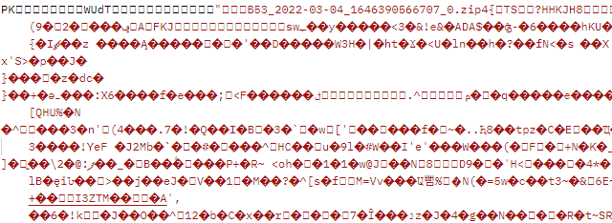

## Post Consolidated Unrated CDRs

This feature enables you to place a request for a consolidated CDR file through APIs.

Up to 90 days of CDRs can be requested, e.g. a consolidated file of a week’s worth of CDRs and these files will be delivered to both Colt Online & APIs.

### Description

POST/generateConsolidatedUnratedCallDetailRecord API allows you to initiate consolidated unrated CDR file generation

### Input parameter(s)

|  |  |  |
| --- | --- | --- |
| Parameter | Type | Description |
| **HTTP Headers** | | |
| x-tracking-id | Mandatory | description: Unique identifier for the order  *example: abcd456e-d45645-dfaafda-1232345667dd*  pattern: ^[\w.~:@-]{1,255}$ |
| Authentication | Mandatory | Bearer Access_token*  Example: Bearer dGVzdDp0ZXN0MTIz |
| **Query** | | |
| serviceProfile | Mandatory | string($^[a-zA-Z0-9]{1,5}$) |
| productOffering | Mandatory | *Voice Line*  *SIP Trunking*  *IP Voice Line*  *IN For Resellers*  *Wholesale SIP*  *CIC for Resellers*  *CIC Opc Reseller* |
| fromDate | Mandatory | string($date) *example: 2019-05-17*  date time in ISO 8601 format |
| toDate | Mandatory | string($date) *example: 2019-05-17*  date time in ISO 8601 format |

***\*Please note:*** ‘Authorization’ should have Type as ‘Oauth 2.0’ and you need to provide Access_token received via ‘Authentication API’

### Response

#### Response Schema

|  |  |  |
| --- | --- | --- |
| order |  |  |
|  | {  href | string *example: https://apigw-uat.colt.net/usageManagement/v1/consolidatedCallDetailRecord/{orderId}* |
|  | orderId  } | orderIdType  string($[A-Za-z0-9\-]{1,36}) |

**Headers:**

|  |  |  |
| --- | --- | --- |
| Name | Description | Type |
| Content-Type |  | string *Example: multipart/form-data; boundary=645501572420247968528808* |
| APIGWTrackingId | Id to track the request end to end | string *Example: abcd456e-d45645-dfaafda-1232345667dd* |

#### Sample success response

|  |
| --- |
| Sample success response |
| {  "order": {  "orderId": "2023092012"  }  } |

## Get Consolidated unrated CDR

Within 2 hours the consolidated CDR file will be available for download via APIs which you used in your request.

The consolidated CDR file will be available to download for 5 days, after that the file will be removed and you will need to submit a new request (if you have not downloaded it).

All Consolidated CDR files delivered have a filename in the following format:-

<profile><orderID>.cdr.zip.

Where:

* <profile> is up to 5 alphanumeric and is the applicable profile for the product
* <orderID> is the combination of date and unique number returned after requesting for consolidated CDR
* .cdr is the extension
* .zip is where the file is zipped

Example: AM220120110182.cdr.zip

The content of the consolidated CDR file is the same as the standard twice daily delivered CDRs, as described in *section 6*

### Description

GET/consolidatedUnratedCallDetailRecord API allows you to get consolidated unrated CDR file based on orderID received.

### Input parameter(s)

|  |  |  |
| --- | --- | --- |
| Parameter | Type | Description |
| **HTTP Headers** | | |
| x-tracking-id | Mandatory | description: Unique identifier for the order  *example: abcd456e-d45645-dfaafda-1232345667dd*  pattern: ^[\w.~:@-]{1,255}$ |
| Authentication | Mandatory | Bearer Access_token*  Example: Bearer dGVzdDp0ZXN0MTIz |
| **Query** | | |
| serviceProfile | Mandatory | string($^[a-zA-Z0-9]{1,5}$) |
| orderID | Mandatory | string($[A-Za-z0-9\-]{1,36}) |

***\*Please note:*** ‘Authentication’ should have Type as ‘Oauth 2.0’ and you need to provide Access_token received via ‘Authentication API’

### Response

The Response to the request will always be in a zipped file.

#### Response Schema

string($binary)

**Headers:**

|  |  |  |
| --- | --- | --- |
| Name | Description | Type |
| Content-Type |  | string *Example: multipart/form-data; boundary=645501572420247968528808* |
| APIGWTrackingId | Id to track the request end to end | string *Example: abcd456e-d45645-dfaafda-1232345667dd* |
| Content-Disposition |  | string |
| x-content-type-options |  | string |

There is no change to the unrated, or rated CDR or non-usage file contents.

#### Sample success response

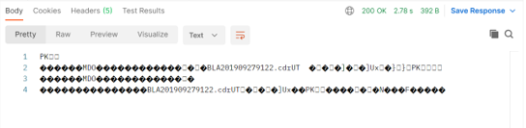

## CDR file details and format

The CDR file contains only CDR records in a fixed length format. A CDR file is made available twice per day – once in the morning and once in the afternoon. The files are delivered at approximately 9AM and 5PM CET.

* The 9 AM CET file contains calls from 4PM CET the previous day until 8AM CET on the current day
* The 5 PM CET file contains calls from 8AM CET to 4PM CET on the current day

**Please note** that CDR files are delivered to your directory 7 days a week and will vary in size depending on the level of traffic that your customers generate.

**Please note** the exception is for the Global SIP countries such as Luxembourg, the Czech Republic, Slovakia & Romania, where the unrated CDRs are delivered daily at approximately 9 AM CET.

### CDR File Format

### *Character Coding*

ASCII

### *File Mark-up Coding*

* No structured Mark-Up used
* Fixed length records
* Fixed length fields, space filled

### *Compression/Decompression Algorithms*

CDR files are delivered in Zip format (Unix Gzip, MS Windows Zip). However, Colt recognizes that this can be difficult for certain companies to receive and the CDR files can be delivered in plain text if required. Please notify the Colt Customer Services if you need the CDR files to be delivered as plain text (Uncompressed) files.

### *File Name*

All unrated CDR files delivered to Colt Online and APIs have a filename in the following format:-

<countrycode>_<profile>_<productidentifier>_<sequence no>_<date>.cdr.gz

Where:

* <countrycode> in ISO 2 character format
* <profile> is up to 5 alphanumerics and is the applicable profile for the product
* <productidentifier> is the product identifier (1-2 alphanumerics) – see table below
* <sequence no> is a rolling four digit sequence per <profile>_<product> combination
* <date> is YYYYMMDDHHmmss
* .cdr is the extension
* .gz is where the file is zipped

|  |  |
| --- | --- |
| Product Identifier | Product name |
| 00 | Voice Line |
| 10 | SIP Trunking |
| 11 | IP Voice Line (Voice Line (v)) |
| 12 | IN for Resellers |
| 15 | Geographic Number Hosting |
| 19 | CIC for Resellers |
| 20 | CIC Opc Reseller |

Example: DE_ABC_01_0001_20101208090122.cdr.gz

## Call Detail Record format

A standard format for unrated CDRs applies to our reseller and wholesale product portfolio.. This standard CDR format is harmonised across all Colt countries and applies to existing and new products going forward in Colt Online

The data lines are 229 bytes in length and organised as:

|  |  |  |  |  |  |
| --- | --- | --- | --- | --- | --- |
| Ref | Name | Bytes/ Length | Position | Alpha/ Numeric | Format & Description |
| 1 | Origin | 20 | 1 | N | Originating CLI with leading 0. Filler spaces must be added to fill in the spaces designated for a field. In the case of IN, the last 4 digits are replaced with ‘x’.  In the case of Czech Republic (CZ), Poland (PL), Romania (RO) ,Slovakia (SK), Luxembourg (LUX), Finland (FI) ,Norway (NO),  Japan (JP) for SIP Trunking, the Originating CLI starts with the country code  In the case of Global IN for Resellers ordered through the UK, the caller’s number will be in the international format, starting with 00 + the country code + the number (omitting the leading zero) e.g. caller calling from a mobile in Romania: 004074582xxxx |
| 2 | Destination (Terminating) | 20 | 21 | N | Destination 0 = Domestic and National, Destination 00 = International  In the case of Czech Republic (CZ), Poland (PL), Romania (RO) ,Slovakia (SK), Luxembourg (LUX), Finland (FI) ,Norway (NO),  Japan (JP) for SIP Trunking, the destination starts with the country code |
| 3 | Product Type | 2 | 41 | N | ‘01’=Indirect Service  ‘00’ = Direct Service '04' = Direct Service  ’06‘=NH Geo Premium  ‘07’=NH Geo Wholesale  '08'=NH Geo Retail  '09'=NH Geo Incoming  '10'=NH IN Incoming '79' = SIP Trunking  ‘80’ = IP Voice Line (Voice Line (v))  CIC for Reseller is SIP trunk reseller, so cdr format will have product code as ‘79’ |
| 4 | Date | 8 | 43 | N | YYYYMMDD |
| 5 | Time | 8 | 51 | N | HHMMSSss . Time duration is broken up into tenths of a second. Fractions of a second will be ignored. |
| 6 | Duration | 8 | 59 | N | Duration of the call to the nearest 1/10th of a second SSSSSSSs |
| 7 | Continuation | 1 | 67 | N | ‘0’, ‘1’, ‘2’, ‘3’ or ‘5’ – normally a 0. To be used only if calls are greater than 6 hours |
| 8 | Switch ID | 25 | 68 | N | Unique switch identifier |
| 9 | Trunk incoming | 25 | 93 | N | Internal use only |
| 10 | Trunk outgoing | 25 | 118 | N | Internal use only |
| 11 | Account Code | 20 | 143 | A | Not in use |
| 12 | Pulses in | 6 | 163 | N | Not in use |
| 13 | Pulses generated | 6 | 169 | N | Not in use |
| 14 | Pulses sent | 6 | 175 | A | In use for all IN, Voice & VoIP services in UK & France: Charge Band defined by Regulator(Ofcom UK/Arcep FR) for calls to non-geographic numbers. If no Charge Band is available, the value is 000000 or blank. |
| 15 | Service Indicator | 4 | 181 | N | 0000 for standard calls, 0001 for ISDN calls |
| 16 | Charged (C-Num) | 20 | 185 | N | Trunk ID shown here for IP Voice Line (Voice Line (v)) and for SIP Trunking  In use for IN services – the number to which the IN service number is translated.  In the case of Global IN for Resellers ordered through the UK, this number will be in the international format, starting with 00 + the country code + the number (omitting the leading zero) |
| 17 | Dialled (D-Num) | 20 | 205 | N | In use for IN services (IN service number)  In the case of Global IN for Resellers ordered through the UK, the IN service number will be in the international format, starting with 00 + the country code + the number (omitting the leading zero) e.g. Romania freephone number: 0040800890123 |
| 18 | Carrier | 3 | 225 | A | The Reseller profile of up to 3 alphanumerics |
| 19 | End of Record | 1 | 228 | A | Value of zero is shown |
| 20 | Line Feed | 1 | 229 | ASCII Control Character | Line Feed (ASCII Control Character not visible in plain text editors |

**Please note:** There is an ASCII Control Character (Line Feed, HEX 0A) after the last field 19 “End of record”. This Control character generates a new line for the next CDR and shows that the actual CDR ends. Normally you can ignore this control character except you use a HEX-Editor to process your CDRs.

## Sample Call Detail Record

**Sample unrated CDRs for Voice Line:-**

06971041234 0368751234002011093007235400000007301 00063 OF3XBN33687512340 0000010000010000 0368751234 SV0

06971041234 038203731234002011093007225600000013201 00063 OF3XBN33855523484 0000010000010000 038203731234 SV0

06971041234 066311234002011093007250000000001101 00063 OF3EZLA663121234 0000010000010000 066311234 SV0

**Sample unrated CDRs for Voice Line (FR):-**

0982406525 0841118663002015082009134390000074070 03300 1088 1062 000000000000 A0050010 0033899108018PBW0 PBW2S

0494270512 0494107021002015082011415520000000540 03302 1503 1503 000000000000 A0050010 0033826106714PAC0 PAC2S

**Sample unrated CDRs for SIP Trunking:-**

038422001234 081010251234792011060314221108000000000 ZHA CXVIE013038422001234 0000 ABC0

038422001234 0517661234792011060314222708000022440 ZHA CXVIE013038422001234 0000 ABC0

0732388824321 0732771234792011060314261409000013790 ZHA CXVIE0130732388824321 0000 ABC0

0158031234 00351913231234792011060314323700000000210 ZHA CXMAD0130158031234 0000 ABC0

**Sample unrated CDRs for SIP Trunking (CZ, FI, JP, LU, NO, RO & SK):-**

352206099 442033535570792015091610405600 170 0000 ALB0

420296180311 442033535475792015100911120200 550 0000 AAX0

40312200237 40753086507792015070215113800 1480 0000 BKD0

421232335698 390321393652792015092110045300 90 0000 BKE0

**Sample unrated CDRs for IN for Resellers (Freephone & shared cost):-**

0129356xxxx 08003581234002011101923483510000008300 01001 3059 0129356xxxx 0000000000000000000000 01618361234 08003581234ADC0

0773777xxxx 08003581234002011101923455270000068380 01001 2702 0773777xxxx 0000000000000000000000 01618361234 08003581234ADC0

0755747xxxx 08003581234002011101923580620000008090 01001 2042 0755747xxxx 0000000000000000000000 01618361234 08003581234ADC0

**Sample unrated CDRs for Wholesale SIP:-**

0307870098 0230333517082012110610363380000005050 MIA SNCB0103 CXMIT0130307870098 0000 AJC0

0230333517 0307870098092012110610401400000002570 MIA CXMIT013 SNCB01010230333517 0000 AJC0

**Sample unrated CDRs for IN Number Hosting:-**

0230329xxx 800909395002012102610530410000000730 00225 10270230329xxx 0000000000000000000010 3483954697 39800909395AJB0

**Sample unrated CDR for Global IN for reseller (CA, CZ, FI, HK, JP, NO, RO & US):-**

004074582xxxx       0040800890020002018032308352100000000240                    00000                                                  004074582xxxx                         0000                  00       0040800890020DMP0

004074582xxxx       0040800890020002018032308394500000000240                    00000                                                  004074582xxxx                         0000                  00       0040800890020DMP0

**Please Note:** The first CDR file will appear in Colt Online after the first call has been made.

# **Rated CDR**

Every month Colt will deposit a file of rated Call Detail Records (CDR) on the server which provide further details of the total call usage displayed on your Cotltinvoice for our Voice products.

This will contain all of the CDRs collected by the Colt network since the last monthly file.

## Description

GET/ratedCallDetailRecord allows you to fetch the rated CDR.

## Input parameter(s)

|  |  |  |
| --- | --- | --- |
| Parameter | Type | Description |
| **HTTP Headers** | | |
| x-racking-id | Mandatory | description: Unique identifier for the order  *example: abcd456e-d45645-dfaafda-1232345667dd*  pattern: ^[\w.~:@-]{1,255}$ |
| Authentication | Mandatory | Bearer Access_token*  Example: Bearer dGVzdDp0ZXN0MTIz |
| **Query** | | |
| OCN | Mandatory | string  ($^[A-Za-z0-9]*$) |
| BCN | Optional | string  ($^[A-Za-z0-9]*$) |
| invoiceNumber | Optional | String |
| month | Optional | Available values:  Jan, Feb, Mar, Apr, May, Jun, Jul, Aug, Sep, Oct, Nov, Dec |
| year | Optional | string ($^[0-9]{4}$)  *example:* 2025 |

***\*Please note:*** ‘Authentication should have Type as ‘Oauth 2.0’ and you need to provide Access_token received via ‘Authentication API’

## Response

The Response to the request will always be in a zipped file (Binary data).

#### Response Schema

string($binary)

**Headers:**

|  |  |  |
| --- | --- | --- |
| Name | Description | Type |
| Content-Type |  | string *Example: multipart/form-data; boundary=645501572420247968528808* |
| APIGWTrackingId | Id to track the request end to end | string *Example: abcd456e-d45645-dfaafda-1232345667dd* |

There is no change to the unrated, or rated CDR or non-usage file contents.

#### Sample success response

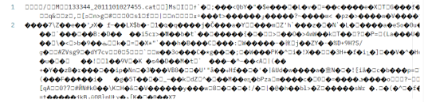

# **Non usage report**

Every month Colt will deposit a file of non-usage charges on the server which provide further details of the total transactional charges displayed on your Colt invoice primarily for our Wholesale SIP/Number Hosting service such as number reservation & activation & port-in activation charges.

This will contain all of the non-usage charges collected by the Colt network since the last monthly file.

## Description

GET/nonUsageReport allows you to fetch the non-usage report.

## Input parameter(s)

|  |  |  |
| --- | --- | --- |
| Parameter | Type | Description |
| **HTTP Headers** | | |
| x-tracking-id | Mandatory | description: Unique identifier for the order  *example: abcd456e-d45645-dfaafda-1232345667dd*  pattern: ^[\w.~:@-]{1,255}$ |
| Authentication | Mandatory | Bearer Access_token*  Example: Bearer dGVzdDp0ZXN0MTIz |
| **Query** | | |
| OCN | Mandatory | string  ($^[A-Za-z0-9]*$) |
| BCN | Optional | string  ($^[A-Za-z0-9]*$) |
| invoiceNumber | Optional | String |
| month | Optional | Available values: Jan, Feb, Mar, Apr, May, Jun, Jul, Aug, Sep, Oct, Nov, Dec |
| year | Optional | string ($^[0-9]{4}$)  *example: 2025* |

***\*Please note:*** ‘Authentication’ should have Type as ‘Oauth 2.0’ and you need to provide Access_token received via ‘Authentication API’

## Response

The Response to the request will always be in a zipped file (Binary data).

#### Response Schema

string($binary)

**Headers:**

|  |  |  |
| --- | --- | --- |
| Name | Description | Type |
| Content-Type |  | string *Example: multipart/form-data; boundary=645501572420247968528808* |
| APIGWTrackingId | Id to track the request end to end | string *Example: abcd456e-d45645-dfaafda-1232345667dd* |

There is no change to the unrated, or rated CDR or non-usage file contents.

#### Sample response schema

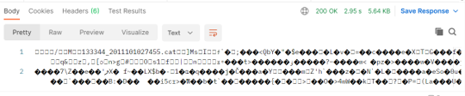

# **How to save/extract binary file**

Please see below steps:

1. Save response to a file

Save to a file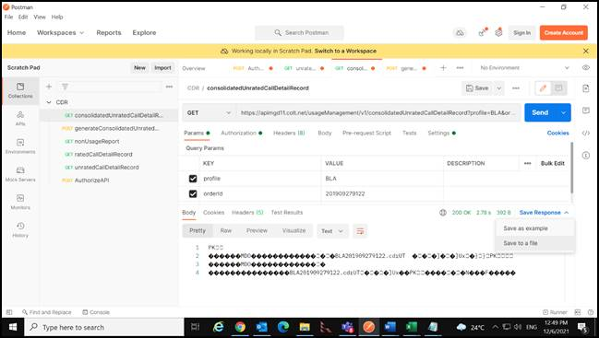

1. Select your folder where you want to save the file and click on ‘Save’

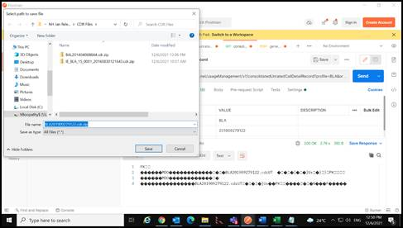

1. To access the file, open your saved location. You’ll find the zip file. This Zip file will contain the CDR file.

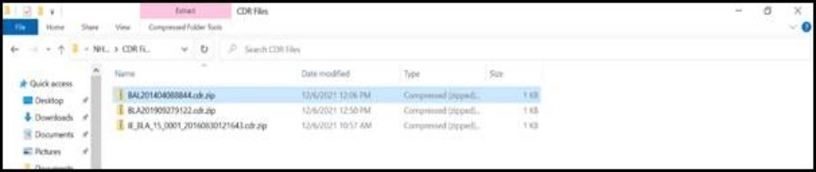      
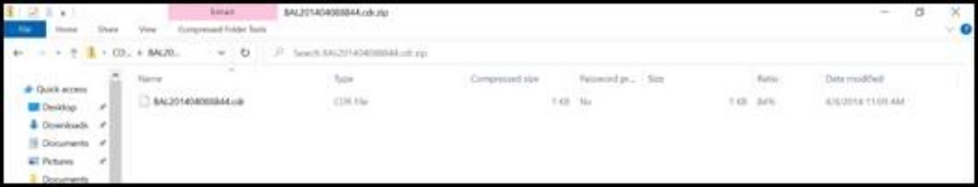              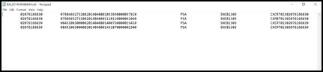  

# **APPENDIX A: API Specifications**

## OAS Specification for Authentication

|  |  |
| --- | --- |
| Type | Attachment |
| YAML | [***OAS specification***](https://developer.colt.net/sites/default/files/2025-01/authorization_v1.0.0_28Nov2024%20%281%29_0.yaml) |

## OAS Specification for Billing APIs

|  |  |
| --- | --- |
| Type | Attachment |
| YAML | [***OAS specification***](https://developer.colt.net/sites/default/files/2025-03/Call%20Detail%20Records%20API_v1.0.0_06Feb2025.yaml) |

# **Appendix B: Country Codes**

|  |  |
| --- | --- |
| Country Code | Country Name |
| AT | Austria |
| BE | Belgium |
| DE | Germany |
| ES | Spain |
| FR | France |
| GB | Great Britain |
| IE | Ireland |
| IT | Italy |
| NL | Netherlands |
| SE | Sweden |
| DK | Denmark |
| PT | Portugal |
| CH | Switzerland |
| LU | Luxembourg |
| CZ | Czech Republic |
| SK | Slovakia |
| RO | Romania |
| PL | Poland |
| FI | Finland |
| NO | Norway |
| JP | Japan |