Introduction
This document describes the Colt Wholesale SIP (Number Hosting) 17th Oct 2026 release.
The release will focus on:-
- Decommissioning of SOAP/HTTPs APIs
- Address Management & Directory Service in Spain
- Spain - updated Number Types
- Introduction of Digital Letters Of Authorisation for porting in Austria
- New Denmark Port-in Deactivation and Reactivation process
- Numbers on Demand (NOD) portal and B2B API improvements
- Online orders for hosted customer numbers/prefixes in France
These changes might imply development at your end, so please read this document carefully.
The changes in this release require your support during our test period. The Customer UAT is planned from 31st Aug 2026 to 11th Sept 2026. Please get in touch with NumberHostingUATSupportTeam@COLT.NET if you would like to participate in the UAT.

Document change control
Version | Change description
V1 | 17th Oct Release note
V2 | Updates:  - Updated section Address Management & Directory Services in Spain with details related to CLI level DSU update (optional)  - New section added Spain Number Types highlighting the changes for Spain  - Valdiation update of companyRegistrationNumber for AT in section Digital LOA (Austria)  - Updated OAS specification for number management in section Appendix A: API specifications

Wholesale SIP REST APIs

Current SOAP/HTTPs APIs – decommissioning

As communicated on 26th May 2026, we would like to remind you that you should be aligning your resources to complete the transformation to our new Authentication, Number Management & Address Management REST APIs on our Apigee platform ahead of the decommissioning of current SOAP/HTTPs and address validation APIs on 17th Oct 2026. If you do not take action, then you will not be able to raise orders with Colt after 17th Oct 2026!
To help with your move, you will be able to register on our API developer portal where you will then be able to self-serve and use a “try it out” feature.
If you would like support from our experts, then our API Onboarding team are also available, which is a chargeable option. Please contact your Account Manager for more information.
Please note that the sandbox end point URLs for the SOAP/HTTPs and address validation REST APIs will also be decommissioned and will no longer be available for testing.
These SOAP/HTTPs and address validation APIs are being decommissioned:-
SOAP/ HTTPS/ REST | Production | Sandbox
SOAP | WSDL URL  https://wbmdmzis02.colt.net/ws/ColtNumberHosting.common.webSvcProvider:numberHosting?WSDL  End point URL  https://wbmdmzis02.colt.net/ws/ColtNumberHosting.common.webSvcProvider:numberHosting/ColtNumberHosting_common_webSvcProvider_numberHosting_Port | WSDL URL  https://wbmdmzis351.colt.net/ws/ColtNumberHosting.common.webSvcProvider:numberHosting?WSDL  End point URL  https://wbmdmzis351.colt.net/ws/ColtNumberHosting.common.webSvcProvider:numberHosting/ColtNumberHosting_common_webSvcProvider_numberHosting_Port
HTTPS | https://wbmdmzis02.colt.net/invoke/ColtNumberHosting.common.http/ + API name | https://wbmdmzis351.colt.net/invoke/ColtNumberHosting.common.http/ + API name
REST | validGeographicAddress API https://wbmdmzis02.colt.net/rest/ColtNumberHosting/common/restSvc/v1/validGeographicAddress | https://wmisd351.colt.net/rest/ColtNumberHosting/common/restSvc/v1/validGeographicAddress

In the table below please find the REST Apigee API details mapped against the existing SOAP/HTTPs APIs.

Operation(s) | Current end point PRODUCTION URLs  SOAP/HTTPs  (to be decommissioned on 17th Oct 2026) | New end point URL  REST Apigee API
Authentication API
Authenticate APIs | No authentication API  Basic auth is used- username/password | New Authentication API: Industry standard authentication and authorisation mechanism  OAuth 2.0 access token (applicable for 30 mins only) with client_credential grant type used to authenticate clients  https://apis.colt.net/authentication/v1/oauth/token
WSIP Number Management
Search free number(s) | https://wbmdmzis02.colt.net/invoke/ColtNumberHosting.common.http/numberEnquiry | https://apis.colt.net/numberManagement/v1/freeNumber
Search number(s) from inventory | https://wbmdmzis02.colt.net/invoke/ColtNumberHosting.common.http/numberEnquiry | One common API to search numbers from your inventory using status, orderID, customer reference or CLI and get the CLI level details by providing CLI in input.  https://apis.colt.net/numberManagement/v1/number
Get number details at CLI level | https://wbmdmzis02.colt.net/invoke/ColtNumberHosting.common.http/getNumberDetail
Reserve number(s) | https://wbmdmzis02.colt.net/invoke/ColtNumberHosting.common.http/numberReservation | https://apis.colt.net/numberManagement/v1/reservation/order
Activate number(s) including Pre-activation | https://wbmdmzis02.colt.net/invoke/ColtNumberHosting.common.http/numberActivation | https://apis.colt.net/numberManagement/v1/activation/order
Cancel number reservation | https://wbmdmzis02.colt.net/invoke/ColtNumberHosting.common.http/cancelReservation | One common API to return numbers to Colt  https://apis.colt.net/numberManagement/v1/return/order
Deactivate number(s) | https://wbmdmzis02.colt.net/invoke/ColtNumberHosting.common.http/numberDeactivation
Port-in number(s) | https://wbmdmzis02.colt.net/invoke/ColtNumberHosting.common.http/portIn | https://apis.colt.net/numberManagement/v1/portIn/order
Update port orders  Change date, cancel, schedule, send notes, accept/reject port-out | https://wbmdmzis02.colt.net/invoke/ColtNumberHosting.common.http/updatePortIn  https://wbmdmzis02.colt.net/invoke/ColtNumberHosting.common.http/cancelPortIn  https://wbmdmzis02.colt.net/invoke/ColtNumberHosting.common.http/transactionDataUpdate | One common API to update port in/out orders  https://apis.colt.net/numberManagement/v1/portUpdate/order
Update customer details  end customer details, address, Directory services details | https://wbmdmzis02.colt.net/invoke/ColtNumberHosting.common.http/updateEndCustomerAddress  https://wbmdmzis02.colt.net/invoke/ColtNumberHosting.common.http/updateDirectoryServices | https://apis.colt.net/numberManagement/v1/updateCustomer/order
Reactivate number(s) | https://wbmdmzis02.colt.net/invoke/ColtNumberHosting.common.http/numberReactivation  https://wbmdmzis02.colt.net/invoke/ColtNumberHosting.common.http/portInReactivation | https://apis.colt.net/numberManagement/v1/reactivation/order
Get order history of a number / range | https://wbmdmzis02.colt.net/invoke/ColtNumberHosting.common.http/getTelephoneNumberHistory | https://apis.colt.net/numberManagement/v1/CLIOrderHistory
Get order details | https://wbmdmzis02.colt.net/invoke/ColtNumberHosting.common.http/getNumberDetail | https://apis.colt.net/numberManagement/v1/order/{orderId}
Get order list | https://wbmdmzis02.colt.net/invoke/ColtNumberHosting.common.http/getTransactionList | https://apis.colt.net/numberManagement/v1/order
Bulk action | https://wbmdmzis02.colt.net/invoke/ColtNumberHosting.common.http/bulkNhTransactions | https://apis.colt.net/numberManagement/v1/bulkActivationOrder
Bulk action |  | https://apis.colt.net/numberManagement/v1/bulkPortInOrder
Bulk action |  | https://apis.colt.net/numberManagement/v1/bulkUpdateCustomerDetailsOrder
Address Management APIs
Validate address | https://wbmdmzis02.colt.net/rest/ColtNumberHosting/common/restSvc/v1/validGeographicAddress | https://apis.colt.net/addressManagement/v1/validateAddress
Get LAC by location |  | https://apis.colt.net/addressManagement/v1/LACByLocation
Get address associated with addressId |  | https://apis.colt.net/addressManagement/v1/address/{addressId}

We have introduced these new REST APIs on the Apigee platform which you can take advantage of:-

Operation(s) | New end point URL  Apigee REST APIs
Number Management APIs
Check portability | https://apis.colt.net/numberManagement/v1/checkPortability
Get free number count (JIT) | https://apis.colt.net/numberManagement/v1/freeNumberCount
Lock free numbers (JIT) | https://apis.colt.net/numberManagement/v1/lockFreeNumbers
Request free number backfill | https://apis.colt.net/numberManagement/v1/freeNumberBackfill/order
Cancel free number backfill request | https://apis.colt.net/numberManagement/v1/cancelFreeNumberBackfill/order
Pre Order Validation* | https://apis.colt.net/numberManagement/v1/preOrderValidation/order
Number Coverage* | https://apis.colt.net/numberManagement/v1/LACList
Migrate Number(s)* | https://apis.colt.net/numberManagement/v1/migration/order
Download attachment(s)* | https://apis.colt.net/numberManagement/v1/order/{orderId}/attachment
Voice Common Services APIs
Validate customer registration number  - available for PT, ES and FI | https://apis.colt.net/common-services/v1/check-vat-number
Holiday Calendar* | https://apis.colt.net/common-services/v1/holidayCalendar
Port-In operator list* | https://apis.colt.net/common-services/v1/portInOperatorList

*APIs will be available from 18th July 2026.

Billing APIs are also offered. Please refer to the OAS specification (Appendix A: API specifications) for details.

Address Management & Directory Services in Spain

As part of new regulatory requirements in Spain, address information must comply with the INE Electoral Street Directory (Callejero INE). To meet this requirement, address verification and validation within Colt will be performed against the INE Callejero dataset, which will be fully loaded into Colt’s Address Management System.
To ensure regulatory compliance, few changes relating to address management, validation, and directory services will be introduced.
- New fields will be added for Spain and are marked as ‘New’ in the table below. Some validation of existing fields will also be updated. Fields which are changing are marked ‘Update’.
- 3 new Optional fields in Address structure - Stairs, Floor Number, Door Number.
- 1 new Optional field in DSU structure - Additional Notes(DSU).
All changes are applicable in Spain (ES) for number Activation, new Port-In & Address Update operations. The fields are described in the table below:
Element | Description | Change | Current Type | Current Length | Updated Type | Updated Length | Customer Action
End customer Name and details
endCustomerName | It is the end customer name for whom numbers will be activated. | No change | M | L ≤ 255 | - | - | -
cifNif/ companyRegistrationNumber | Also known as CIF/NIF number | No change | M | L ≤ 20 | - | - | -
companyNumberRegistered | if your VAT number/CIF/NIF is not registered then you can provide this field in the request with value as false and system will not fail your request.  If true/no value provided, system will validate the values against the VIES API. | No change | O | LOV | - | - | -
premisesNumber/ houseNumber | Number of the building | No change | M | L ≤ 10 | - | - | -
streetType | Type of street | No change | M | L ≤ 50 | - | - | -
streetName | Name of the street | No change | M | L ≤ 200 | - | - | -
cityTown | Name of the City/town. | No change | M | L ≤ 100 | - | - | -
province | Name of the province | No change | M | L ≤ 50 | - | - | -
postalZipCode | Postal Code | No change | M | L = 5 | - | - | -
floorSuite | Floor number or reference | New | - | - | O | L ≤ 20 | New Optional Field
stairs | Stairs detail | New |  |  | O | L ≤ 20 | New Optional Field
doorNumber | Door number | New | - | - | O | L ≤ 10 | New Optional Field
addressID | Either the complete address or addressID is required in the request | No change | CM | L ≤ 20 | - | - | Either the complete address or addressID is required in the request
Directory services update (Mandatory Node)
Parent Start telephone Number | Conditional Mandatory at the order level. startFullNumber and endFullNumber with multiple number ranges or multiple individual CLIs are provided if the operation type is Activation and Portin Activation. | New | - | - | CM | L =11 | Allowed pattern: +{country code}{phone number without leading zero}
Parent End Telephone Number |  | New | - | - | CM | L =11 | Allowed pattern: +{country code}{phone number without leading zero}
Basic Directory Entry/ basicDirectoryEntry | Confirms consent or not to publish user data in guides / consultation services. | No change | M | LOV | - | - | allowed values:  - true  - false
directSalesMarketingEntry | Confirms consent or not to data being published in guides / services used for commercial or advertising purposes. | Update | M | LOV | - | - | allowed values:  - true  - false  If Basic Directory Entry is "true" then Direct Sales/Marketing Entry can be "true or false".  If Basic Directory Entry is "false" then Direct Sales/Marketing Entry must be "false".
additionalInstructions | Additional notes/instruction | New | O | L ≤ 255 | - | - | New Optional section to provide additional instructions (if any)

Digital LOA (Austria)
We are extending the countries in which we support a new optional Digital Letter of Authorization (DLOA) in this release to Austria. The DLOA is an electronic version of the traditional Letter of Authorization for port in requests and will allow your end customer to electronically sign the LOA using Docusign.
The DLOA is generated based on the information provided by you in the port-in order raised in our Numbers on Demand portal or over API. We will then generate the DLOA with the information you have populated in the order and send it to your end customer who must then sign it digitally. The signed DLOA will then be stored against the port-in order for future reference.
This functionality is optional. If you have your own DLOA functionality then you can opt not to use this feature and to manually upload your end-customer’s LOA in our port-in order.
The benefits of using the DLOA are:
1. Increased Efficiency
- Faster Processing: DLOAs can be created, sent, and signed instantly, cutting down the delays associated with manual workflows
- Automated solution: Easily integrates into digital workflows and systems
2. Improved Accuracy
- Template Standardization: Reduces errors by using a standardized digital form.
- Quick Validation: required fields are validated in real time
3. Enhanced Security
- Digital Signatures: Ensures authenticity and integrity of the document using DocuSign secure digital envelopes.
4. Convenience
- Remote Access: Stakeholders can authorise from anywhere, without the need to print, sign, and scan documents
- Device Compatibility: Can be signed on computers, tablets, or smartphones
5. Cost Savings
- Reduced Paper and Printing Costs: Eliminates the need for physical documents.
- Lower Administrative Overhead: Less time spent on document management and mailing logistics.

Current Port-In process / manual journey – no change
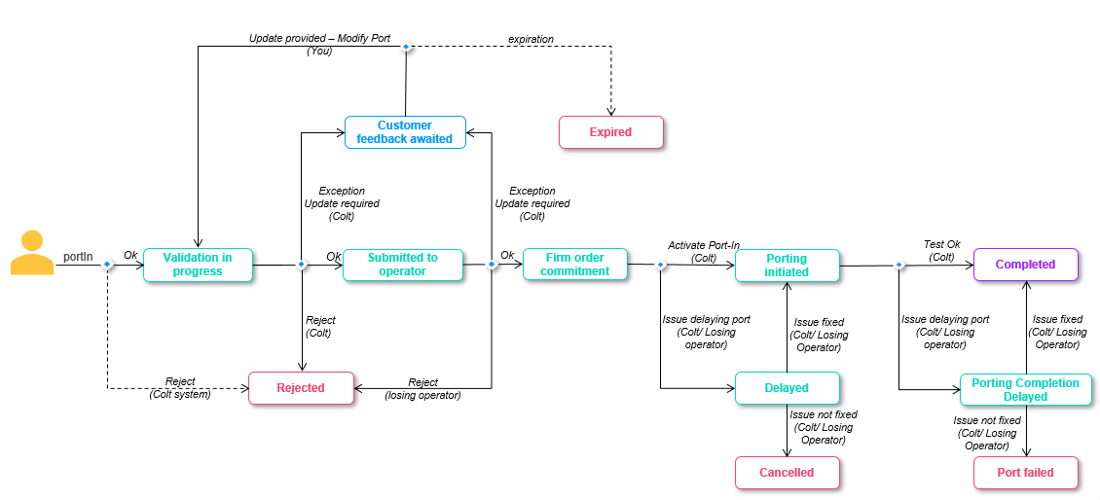

New DLOA Port-In process
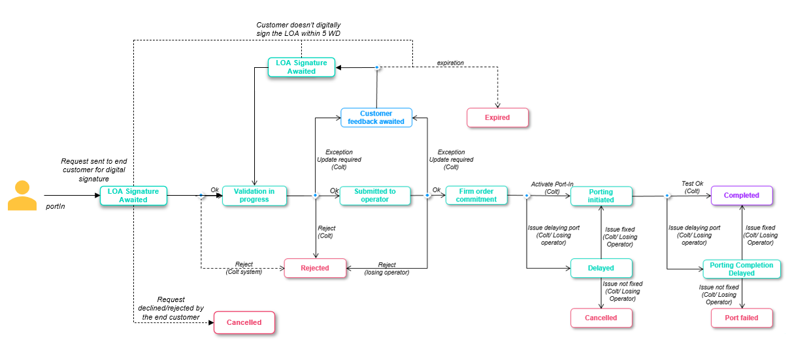
When you submit the portIn request using NOD/API with DLOA as ‘True’ then
  - The request will move to ‘LOA Signature Awaited’ status
    - callBack API notifications, order details screen/API will be enabled with this new status
  - Your end customer will receive the port-in request for digital signature, using the end-customer’s email ID you provide in the port-in order.
The DLOA must be signed within 5 working days otherwise it will expire
  - If signed successfully, Colt will move the order to ‘Validation In progress’ status and our porting desk will receive the order for validation.
    - You will be notified by email (and by callBack if in use) regarding this
    - We will automatically update the porting date if we see that the porting date no longer adheres to the porting lead time (e.g. if the end customer is taking time to sign the DLOA) and you’ll find the details in the email notification and order details.
  - If the DLOA is not signed by the end customer and the link expires after 5 days, then the port-in order will move to ‘Expired’ status.
    - You will be notified by email (and by callBack if in use) regarding this
  - An end customer can also decline/reject the DLOA signature request from their end. In this case the port-in order will move to ‘Cancelled’ status.
    - You will be notified by email (and by callBack if in use) regarding this
  - The Porting Desk can put the order into ‘Customer Feedback Awaited’ status like today to get more details from you. If you update the telephone number (Add new numbers, modify/remove existing numbers) in the ‘Modify Port’ request, the request will again go to your end customer for DLOA signature and the order status will be ‘LOA Signature Awaited’.

DLOA email and link
Email Link Expiry: Links in email notifications will expire after 48 hours or more than 5 consecutive clicks.
If a link expires, the signing authority gets an option to ‘Send New Link’. The Signing authority will receive a new email with a new link.
DLOA expiry: If the DLOA is not actioned by the customer within 5 working days, the order will be ‘Expired’ in the system and the DLOA will also expire. Post document expiry it cannot be viewed or signed by the signing authority.
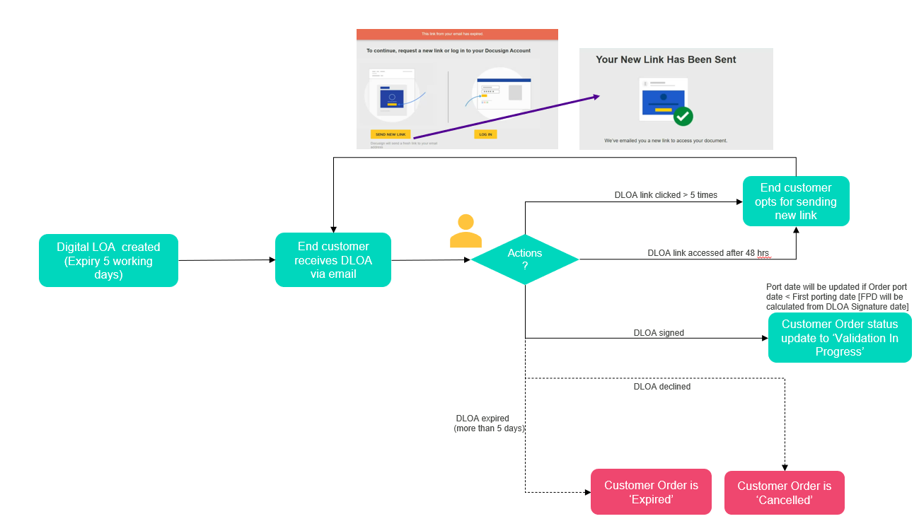

Sample emails
DLOA Signature:
- Email to reseller-
Subject line: Porting Letter of Authorization - Order ID : {orderId}
Email content:
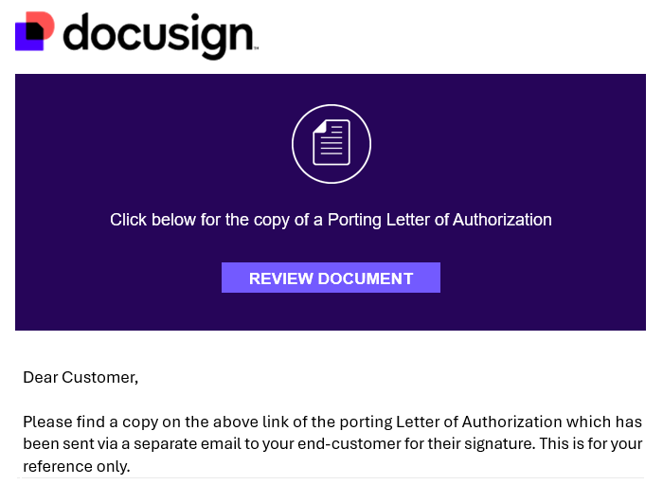
- Email to end customer-
Subject line: Porting Letter of Authorization - Order ID : {orderId}
Email content:
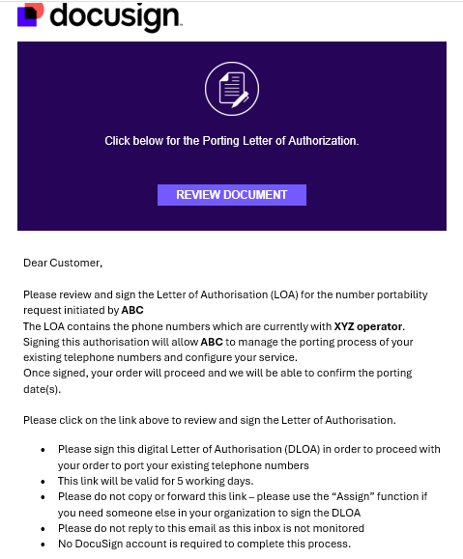

DLOA successfully signed by the end customer
- Email to reseller and end customer-
Subject line: Completed: Porting Letter of Authorization - Order ID : {orderId}
Email content:
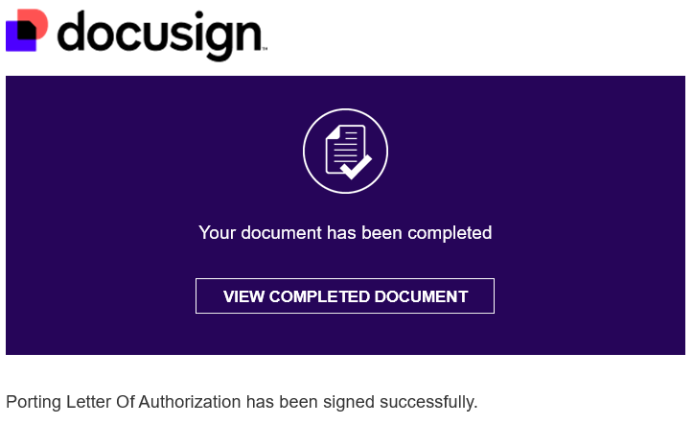

DLOA declined by the end customer
- Email to reseller and end customer-
Subject line: Declined: Porting Letter of Authorization - Order ID : {orderId}
Email content:
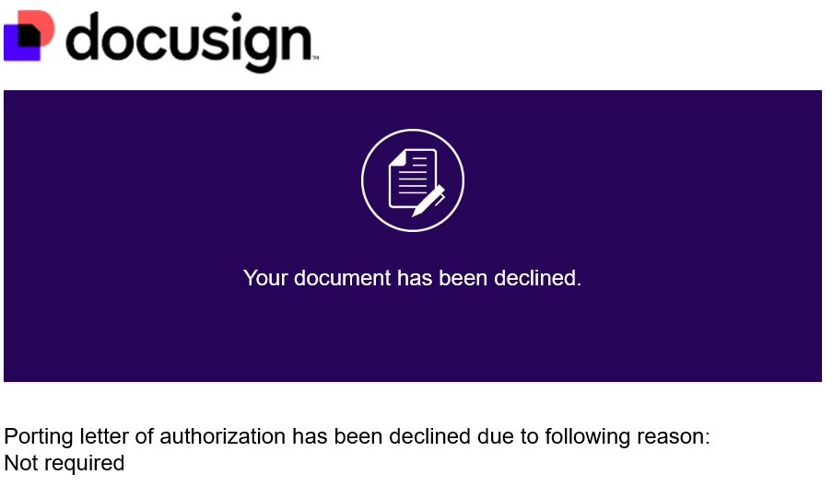

DLOA link expired after 5 working days
- Email to reseller and end customer-
Subject line: Voided: Porting Letter of Authorization - Order ID : {orderId}
Email content:
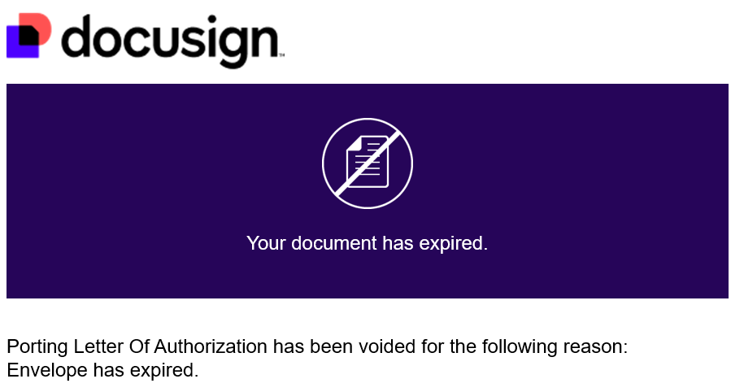

NOD and API impacts:

The DLOA is an optional feature. You have an option to continue with the manual process or opt for the new DLOA journey.
Impacted Functionality:
- NOD: Port -in, Modify Port and Bulk Port In
- new Apigee APIs: POST/v1/portIn/order and POST/v1/portUpdate/order

Field level details:
Fields/sections | Impact | Manual Journey | DLOA Journey
Digital LOA / digitalLetterOfAuthorityFlag | New Optional field  NOD: Digital LOA  Tick box  (Default: Unticked/ Manual)  Apigee API: digitalLetterOfAuthorityFlag  Allowed values: True, False (Default) | If the flag is not ticked on NOD or no value/ ‘False’ is sent in the API request, then the existing manual process will continue. | If the flag is ticked or the value is sent as ‘True’ in the API request, the DLOA journey will be initiated.
Customer Name/ endCustomerName | No Change | Mandatory | Mandatory
Company Registration Number / companyRegistrationNumber | New optional field  - Allowed length: 7  - Allowed format: 3 to 6 digits followed by one check letter.  - E.g. 622577f, 41848t, 4620w, 404w. | NA | Optional
Customer Reference | No Change | Optional | Optional
End Customer current address | No Change | Mandatory | Mandatory
End Customer new address | No Change | Optional | Optional
Telephone Numbers | No Change  max 1 number per order | Mandatory | Mandatory
Main Billing Number (MBN) | No Change | Mandatory at range level | Mandatory at range level
Single or Multi Line | No Change | Optional | Optional
Letter of Authorization | No Change for manual journey  Not required for the DLOA journey as it will be auto-generated and sent to the end-customer via Docusign | Mandatory | Not applicable
Invoice Document/ Supplementary Form | No Change | Optional | Optional
Porting Date | No Change | Mandatory | Mandatory
Porting Window | No Change | Mandatory | Mandatory
Current Operator | No Change  NOD: Current Operator  Apigee API: currentOperator | Mandatory | Mandatory
Porting Contact details (port update notifications are sent to the email address present in this section) | No Change | Optional | Optional
Digital LOA details / signatoryDetails  (your end-customer will receive the DLOA for signature via DocuSign - the email ID must be of the end-customer’s signatory because the docusign email cannot be forwarded on by the end-customer) | Mandatory for DLOA journey  Sender details (you will be the sender of the email triggered to the end customer and the details provided below are what your end-customer will see. This is an optional node- if not provided, it will automatically fetch the sender details from Colt’s database)  NOD: Your Company Name (M) and your Email Address (M)  Apigee API: senderCompanyName (M), senderEmail (M)  Recipient/Signing Authority details (your end customer who will receive the LOA for digital signature)  NOD: First Name (M), Last Name (M), Email Address (M)  Apigee API: signingAuthorityFirstName (M), signingAuthorityLastName (M), signingAuthorityEmail (M) | Not applicable | Mandatory

Denmark port-in deactivation & reactivation

Current process:

Today, when a deactivation request is submitted for Port-In Activated number(s) in Denmark, an email is sent to Colt’s Local Porting Desk for manual processing.
Once the Porting Desk completes the request:
- The order is Completed.
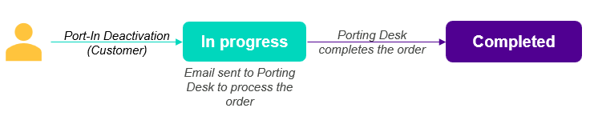
- The number status is updated to Returned
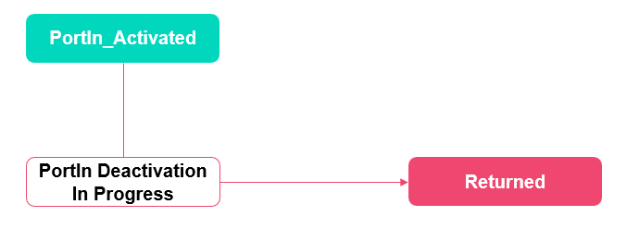

New process:

In this release, the deactivation process for Port-In Activated number(s) will be automated for Denmark. Once deactivated, the number(s) will move to Port-In Quarantined status for a period of 30 days.
During the 30-day quarantine period
- The order status will be Number Deactivated.
- Number(s) can be reactivated during this period, in which case they will move back to Port-In Activated status.
Reactivation Details
- Action: Cancel
- Apigee API: v1/portUpdate/order
- NOD: My Orders page
The Colt Porting Desk can also perform the cancellation on behalf of the customer, which will return the number(s) to Port-In Activated status.
After the 30-day quarantine period
If no action is taken within 30 days:
- The order status will change to Quarantine Completed.
- The Porting Desk will initiate the process of returning the number(s) to the original range holder.
- Once the return process is completed:
  - The order status will be updated to Completed.
  - The number status will change from Port-In Quarantined to Returned.
Customers will be notified of these updates via email and callback notifications (if subscribed).
New Number lifecycle:
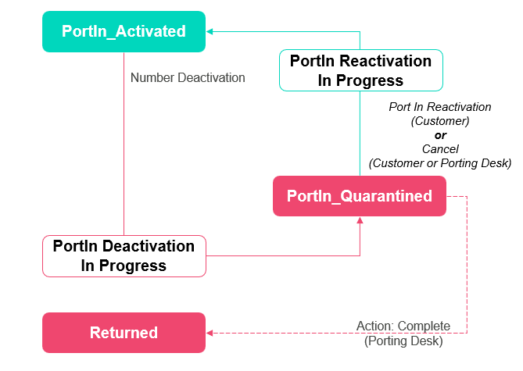
New Order lifecycle:
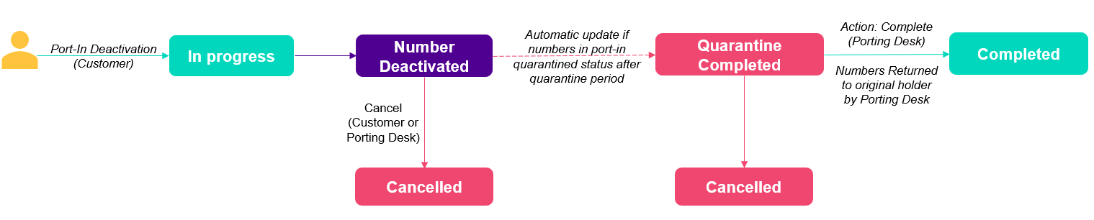

Spain Number Types
Today Wholesale SIP offers Geo, Geo Nomadic and Nomadic Numbers for Spain.
October release brings new changes to the number types on offer.
Geo Nomadic Numbers
- All Geo-nomadic LACs will now be offered as Geographic Numbers only
- Geo-nomadic number search option will be removed from NOD
- Apigee /v1/freeNumber API: You can search for free Geo Nomadic numbers by passing numberType as GEOGRAPHICAL_NUMBERS or GEOGRAPHICAL_NOMADIC_NUMBERS. This means there is no impact on API users with this release
- Port-in/out and migrations will now be possible on numbers previously listed as Geo-nomadic
400 Commercial Calls
The Spanish Secretary of State for Telecommunications and Digital Infrastructure. has introduced a new numbering framework that builds upon a broader telecom and consumer protection framework.
This 2026 resolution introduces:
- A dedicated "400" prefix exclusively for commercial calls
- A requirement that all telemarketing / sales / promotional calls use this range
- Mandatory blocking of non-compliant calls once enforcement is active
- "400" range numbers are designed for outbound use only and called parties cannot call these numbers. This enables calls to be clearly identifiable as commercial calls to the called party.
Our NOD/API changes go live the day after the enforcement date of 16 October:-
- A new LAC 400 will be offered under ‘Location Independent Numbers’ in NOD
- A new optional LAC field will be introduced for Spain where a user can provide 400 or 51X as input with the numberType as LOCATION_INDEPENDENT_NUMBERS
  - If no LAC is passed, by default 51X numbers will be returned in the response
  - There is no impact on existing API users
- LAC validation will not be applicable on 400 numbers
- Port-in/out and migrations will be possible for 400 numbers
To summarize the key differences of the different Spanish number types, please see the table below:-

Number Types | ‘Geo’ | ‘Geo-nomadic’ | ‘Nomadic’ | Commercial Calls
Description | LAC can be used within the province for a city / town |  | LAC can be used across Spain | LAC can be used across Spain
Local Area Codes (LACs) | Please refer to the Number Coverage file: https://developer.colt.net/wholesale-sip-documentation |  | 512/516 | 400
Free Number Search | Yes | Yes | Yes | Yes
LAC Validation | Yes | Yes | No | No
Port-in/ Port-Out | Yes | Yes | No | Yes
Migrations (other product to WSIP) | Yes | Yes | No | Yes
Inter/Intra domain migrations | Yes | Yes | Yes | Yes
Quarantine Period | 30 calendar days |  |  | 30 calendar days

Numbers on Demand (NOD) and B2B API improvements
Below are 10 improvements targeted for this release. Updated API OAS specifications can be found in the Appendix A: API specifications.
Sr no | Functionality | Interface | Improvement Description | Country Scope | Code Breaking change for customer (Yes/No)
1 | Schedule port screen  Initiate port screen  portUpdate | All | Additional port windows are available during port scheduling (both for Port-in and Port-out)  Current porting windows (Mon-Fri):  0800-0900, 0900-1000, 1000-1100, 1100-1200, 1200-1300, 1300-1400, 1400-1500, 1500-1600, 1600-1700, 1700-1800*, 1800-1900*, 1900-2000*, 2000-2100*, 2100-2200*.  *Tuesdays only  New porting windows (Mon-Sun excluding public holidays):  0000-0100, 0100-0200, 0200-0300, 0300-0400, 0400-0500, 0500-0600, 0600-0700, 0700-0800, 0800-0900, 0900-1000, 1000-1100, 1100-1200, 1200-1300, 1300-1400, 1400-1500, 1500-1600, 1600-1700, 1700-1800*, 1800-1900*, 1900-2000*, 2000-2100*, 2100-2200*, 2200-2300 and 2300-0000.  *Tuesdays- OOH approval required (existing functionality)  These new porting windows are not guaranteed porting windows. Porting is automated and supported in the systems only. The Porting Desk is unavailable during this time. | NL | Yes (code change is only required if the new porting windows are required)
2 | Port Out creation notification | All | The existing sender email ID for Port-out orders will be changed from: WM_lonisb006.internal.colt.net_6666@colt.net  to this new email ID: ColtPortOutNotification@colt.net.  This change is only applicable for "Create Port out " notifications.  Please note this is a “Do not reply” email ID. Please refer to the porting information page for porting desk contact information. | All | Yes (only if the sender email ID is hardcoded)
3 | Port Out | All | New action ‘Delay’ will be added for the UK port-out flow. This action will be performed by UK Porting Desk who will set the confirmed order to ‘Delayed’ if there’s any delay from Colt or from the Gaining Operator.  You will be notified by email and a callBack notification will be sent (if subscribed). | UK | No
4 | Portability Checker | NOD | We are introducing portability checker functionality on NOD to pre-validate port-orders.  Note these are Colt internal checks only, there are no checks with the losing operator. | All | No
5 | Save and Draft port-in request | NOD | You will now be able to save an incomplete port-in request as a draft order at any step after successfully filling in the end customer and number details and before submitting the order.  - If any field validation fails whilst filling in an order then those details will not be saved in the draft order  - There will be a note on screen whilst saving the order as a draft  - A new port-in status ‘Draft’ will be introduced  - The LOA/ other port attachments will be stored in the draft order  - Draft orders will be saved for up to 5 working days  - Draft orders can be opened and edited from 'My Orders' page within 5 working days. After that period these orders will be deleted automatically if not submitted  - A ‘Resume’ and a ‘Delete’ action will be available on the ‘My Orders’ page for ‘Draft’ orders  - When you start editing a ‘Draft’ order, all validations for pre-filled data will happen again  - If you edit a draft order, make changes and keep it saved as draft, this will not extend the original draft period of the order  - Orders in ‘Draft’ status will not be sent to the Colt Porting Desk. The Colt Porting Desk will only receive and work on submitted orders.  - API callBack will not be available for ‘Draft’ orders  - ‘Draft’ orders will not be included in WSIP reports  - For deleted orders (manual/automatic), order details will not be available. | All | No
6 | Port-in  Modify port  Change port-in date | NOD and Apigee API only | Port lead time improvement:- | Norway, Poland and Slovakia | No
  (in working days, includes request date) | NO | PL | SK
  Current lead time | 23 | 16 | 17
  New lead time | 7 | 10 | 10
7 | Free number search/ reservation/ direct activation | NOD | Current behaviour: Today you can either search the free numbers using the Local Area Code (LAC) or you can do a search by city/province and the system will automatically fetch the available free numbers from the number management system.  New behaviour: Search by LAC and city feature will be merged. You can either select the LAC from the dropdown (all Spanish LACs will be displayed) or  If you provide the city/province details, the LAC dropdown will be filtered based on the search, and you can select the applicable LAC. | ES | No
8 | Free Number search | NOD | Now you can request for blocksize=1000 from NOD using the ‘Request Free Number’ functionality with a mandatory justification.  You’ll receive the notification once the Country Number Manager adds the 1k block.  You can then reserve/ activate the numbers using NOD / API | All except DE, AT, PL | No
9 | Bulk activation via My Telephone number page | NOD | You can now select multiple reserved ranges from ‘My Telephone Number’ page and activate it at the same time | All | No
10 | Partial deactivations | All | You can now submit the partial deactivation of sub ranges from the same parent range within the same bulk deactivation request | All | No

Online orders for hosted customer numbers/prefixes in France
We are introducing a new ‘Host My Numbers’ self-service page in our customer portal: Colt Online, under Services, through which you can raise new orders to request Colt host your own numbers/ porting prefixes which you have obtained from the regulator: ARCEP in France.
If you are an administrator of your account on Colt Online you can give your users the ‘Host My Numbers’ role following the October release. Alternatively you can contact your Colt Account Manager.

Colt products in scope
- Wholesale SIP
- SIP Trunking for reseller
- CIC for reseller
- Voice Line (v) for reseller
- Operator Connect

To complete an online order please ensure you have the following:-
- You should have a Colt SIP trunk already set up in France or another country
- You can raise a single order per Colt French OCN with as many number ranges & prefixes assigned by ARCEP as you wish.
- You must have completed your registration with APNF and subscribed to APNF’s services:-
  - Portability with Colt as your OPTA, or an alternative provider as your OPTA
  - Emergency service (LAU)
  - FR CLI Authentication (MAN)
  - For assistance, please read our customer Q&A in English or French.
- You will need to supply/attach the following documentation with your first order. When you submit subsequent orders, some of the documents are already on file, as indicated below:-
  - Your Request to APNF for Service subscription
  - Confirmation from APNF of your Service subscription
  - ARCEP’s Numbers and Prefixes Attribution Document
  - The completed & signed mandate for traffic collection – see templates EN or FR
  - TSO/TVO Mandate – see template in EN or FR or Self-Sign email confirmation from you (if not provided in a previous order)
  - Colt OPTA mandate – see template in EN or FR (if not provided in a previous order)
- Once your order is completed, then you can reserve and activate your hosted numbers using existing methods e.g. via NOD / API for Wholesale SIP.

Please contact your Colt Account Manager to raise a manual order:
- If you want to split a single range from ARCEP across multiple OCNs.
- For Modification/ Cease of existing numbers/ prefixes
- For modification of existing mandates

Appendix A: API specifications

OAS Specification for Authentication APIs

New Apigee REST API:  https://apis.colt.net/authentication | Please click here for updated OAS specification.

OAS Specification for number management APIs

New Apigee REST API:  https://apis.colt.net/numberManagement | Please click here for updated OAS specification.

OAS Specification for address management APIs

New Apigee REST API:  https://apis.colt.net/addressManagement | Please click here for updated OAS specification.

OAS Specification for Voice Common Services APIs

New Apigee REST API:  https://apis.colt.net/common-services | Please click here for updated OAS specification.

OAS Specification for Billing APIs

New Apigee REST API:  https://apis.colt.net/usageManagement | Please click here for updated OAS specification.

